**Activity 3: Cost estimating (20 marks)**

Based on the following data for the refurbishment of 6 inner city trams:

|  |  |  |
| --- | --- | --- |
| **Item** | **Cost/unit** | **Units per tram** |
| Upholstery | $2000 | 24 |
| Lighting | $600 | 12 |
| Control systems | $12,000 | 1 |
| Paint | $40 per sqm | 200sqm |
| Mechanicals | $20,000 | 2 |
| Other spares | $5,000 | 1 |
| Labour | $85 | 2000 |

1. Prepare a cost estimate for the project.
2. If the accuracy of estimates for materials (the first 6 items in the above table) are +/- 15% and labour hours is +/- 5%, provide a range of estimates for this project.
3. What is the 95% confidence estimate for this project. (Refer to Standard Statistical Table, attached)

**A. Cost estimation for the project:**

|  |  |  |  |  |  |
| --- | --- | --- | --- | --- | --- |
| **Sl** | **Item** | **Cost/unit** | **Units per tram** | **Total Cost per Tram** | **Total Cost (6 trams)** |
| 1 | Upholstery | $2000 | 24 | $48,000 | $288,000 |
| 2 | Lighting | $600 | 12 | $7,200 | $43,200 |
| 3 | Control systems | $12,000 | 1 | $12,000 | $72,000 |
| 4 | Paint | $40 per sqm | 200sqm | $8,000 | $48,000 |
| 5 | Mechanicals | $20,000 | 2 | $40,000 | $240,000 |
| 6 | Other spares | $5,000 | 1 | $5,000 | $30,000 |
| 7 | Labour | $85 | 2000 | $170,000 | $1,020,000 |
| **Total** | | | | | **$1,741,200** |

**B. Range of estimates for the project:**

If the accuracy of material estimations increased by 15% and labour hours increased by 5%

|  |  |  |  |  |  |
| --- | --- | --- | --- | --- | --- |
| **S.No** | **Item** | **Cost/unit** | **Units per tram** | **Total Cost per Tram** | **Total Cost (6 trams)** |
| 1 | Upholstery | $2300 | 24 | $55,200 | $331,200 |
| 2 | Lighting | $690 | 12 | $8,280 | $49,680 |
| 3 | Control systems | $13,800 | 1 | $13,800 | $82,800 |
| 4 | Paint | $46 per sqm | 200sqm | $9,200 | $55,200 |
| 5 | Mechanicals | $23,000 | 2 | $46,000 | $276,000 |
| 6 | Other spares | $5,750 | 1 | $5,750 | $34,500 |
| **Total material cost** | | | | | **$829,380** |
| 7 | Labour | $89.25 | 2000 | $178,500 | $1,071,000 |
| **Total** | | | | | **$1,900,380** |

If the accuracy of material estimations decreased by 15% and labour hours decreased by 5%

|  |  |  |  |  |  |
| --- | --- | --- | --- | --- | --- |
| **S.No** | **Item** | **Cost/unit** | **Units per tram** | **Total Cost per Tram** | **Total Cost (6 trams)** |
| 1 | Upholstery | $1700 | 24 | $40,800 | $244,800 |
| 2 | Lighting | $510 | 12 | $6,120 | $36,720 |
| 3 | Control systems | $10,200 | 1 | $10,200 | $61,200 |
| 4 | Paint | $34 per sqm | 200sqm | $6,800 | $40,800 |
| 5 | Mechanicals | $17,000 | 2 | $34,000 | $204,000 |
| 6 | Other spares | $4,250 | 1 | $4,250 | $25,500 |
| **Total material cost** | | | | | **$613,020** |
| 7 | Labour | $80.75 | 2000 | $161,500 | $969,000 |
| **Total** | | | | | **$1,582,020** |

**Total Project Cost Range:**

Considering the combined effect of material and labour fluctuations:

Negative scenario (Worst case): $829,380 (Material Increase) + $1,071,000 (Labour Increase) = **$1,900,380**

Positive scenario (Best case): $613,020 (Material Decrease) + $969,000 (Labour Decrease) = **$1,582,020**

**C. 95% confidence estimate for this project.**

Most likely scenario = $1,741,200

Worst case scenario = $1,900,380

Best case scenario = $1,582,020

Mean = (1,900,380 + 4 X 1,741,200 + 1,582,020)/6

= 1,741,200

SD = (1,900,380 - 1,582,0205)/6

= 53,060

**Z= 1.64**

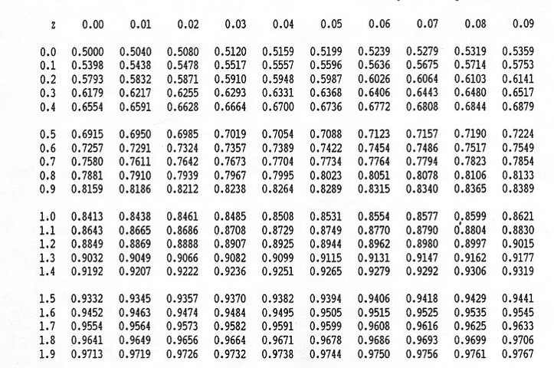

**Z for 95% confidence is 1.64**

Project with 95% confidence is = 1.64 X 53,060 (SD) + 1,741,200 (Mean)

= 1,828,218.4

95% confidence estimate for this project is **$ 1,828,218.4**